Tab 1
Joe Brady
MSBA Mod 2
Machine Learning
12/5/2025
Project Report - Predicting Outcomes at Animal Shelters

Section 1: Introduction

Adopt, don't shop! Every animal deserves a loving home! Animals make your life more joyful! There are many great reasons to adopt an animal, but how do people choose an animal to adopt? What animals spend more time in the shelter before being adopted? What factors make animals more or less likely to get adopted, and can we use this information to improve an animal’s chance of finding a home? If we can deduce these factors, we can prevent animals from getting needlessly euthanized. I adopted a dog about two years ago, and while the experience has been spectacular, the adoption process gave me an up-close look at the challenges that animal shelters face in caring for the many animals in their shelter and finding good homes for these animals.

The inputs for this problem are animal intake and outtake data from the Austin Animal Center of Austin, Texas.^{1, 2} The data contains outcome classification, animal characteristics, intake context, time spent in the shelter, and timing of intake/outcome. The data is from 2013 to 2025. The output is three different XGBoost models:
- A tuned multiclass XGBoost model that predicts outcome classification (adoption, return to owner, euthenasia, transfer)
- A tuned gamma-deviance XGBoost model predicting days spent in the shelter for adopted animals
- A non-tuned logistic regression XGBoost model that predicts adoption or non-adoption. This model is used to extract the most important factors that lead to or prevent adoption

Section 2: Related Work

Upon an initial literature review with help from the tool Elicit, I found 10 studies that examined the same question that I am posing (citations 3 through 12). Most of the studies examined only dogs, with a few examining dogs and cats, and one examining many different animal species. The outcome examined was usually the time between intake and adoption, with a shorter time being the ideal goal. The 10 studies were conducted at various locations, spanning New York to Arizona to the United Kingdom. My analysis differs in that I include a much wider range of animals, and I examine both duration in shelter and probability of adoption outcome as response variable. Additionally, I use machine learning methods for my analysis of the dataset, which is a more powerful tool than is often used in academic research

My analysis aligns with current literature for several factors. Age is a confirmed strong predictor of outcome, with younger animals being adopted more often and earlier than older animals.³ Breed is a strong predictor, with purebred dogs seeing higher likelihood of adoption.³ Although, the preference of breed appears to vary by location based on variance between studies, and is perhaps driven by cultural or geographical factors. The literature also confirmed medical and background factors as good predictors of adoption outcomes. Animal sterilization is a positive factor for adoption⁵ and injury a negative factor for adoption.³ Intake reason (stray, surrendered by owner, etc) is a strong factor as well, with animals previously homed and used to humans having better adoption outcomes.⁸

My analysis on coat color differed from the literature. Studies varied in conclusions as to which coat colors were more or less desirable. One study found that gold, gray, and white coats increased adoption⁸, while another study found no relation.¹⁰ My analysis found that coat color does play a smaller role in predicting outcome, as I will discuss later in Section 6.

There are several factors in the literature that I was not able to analyze due to a lack of data. Behavior data is a strong factor, with positive behavioral traits leading to positive outcomes.¹² Additionally the literature showed that geography is a strong predictor of outcomes. Southern U.S. shelters have worse adoption rates than Northern and Western U.S. shelters.⁶ Additionally, shelters near population centers have better adoption rates.⁴ My dataset did not contain data on these factors as I will discuss in Section 3, and therefore these factors are not in the scope of this project.

Section 3: Data Description

- Raw dataset

I used two datasets for my analysis: animal intake and outtake data from the Austin Animal Center of Austin, Texas.^{1, 2} The intake data contained the following: intake date, found location, intake type (stray, owner surrender, wildlife, etc), intake condition (injured, normal, etc), animal type, breed, and color. The outcome data contained the additional features: birthday, outcome date, outcome (adoption, euthenasia, etc), and gender/sterilization status. The two data tables are unified by an animal ID key column. When combined, the dataset has over 221,000 rows that have both an intake and outcome record.

- Pre-Processing

The data was very messy, and required several steps of pre-processing the merged dataset to get the code into a format that was both suitable for XGBoost and lead to meaningful results:

- There were about 65,000 duplicate animal ID records. Cursory investigation showed that the duplicate records had similar data, but 1 to 2 fields that differed. These fields were not easily resolved - for example, a different outcome type. The duplicates may be caused by entry errors, or by an animal going through the system multiple times. For the sake of time and simplicity, I dropped the duplicate records, keeping only the first instance of the animal ID.This left 155,000 records remaining in the dataset. With more time, a better solution would be to analyze the duplicate records and attempt to either merge the data or select the most realistic/uncompromised entry.
- I split gender/sterilization status into two columns, as they were originally combined. I also simplified sterilization status from “spayed / neutered” to a neutral “sterilized”.
- I calculated several derived features from the datetime columns - age, length of stay in the shelter, outcome month, and outcome weekday.
- I extracted animal type data from the ‘breed’ column. Almost all animal types were given an ‘other’ status in animal type, and then the animal type was stored in some way in the ‘breed’ column. I manually went through the different breeds, identified patterns, learned way to much about the variety of rabbit breeds, and transferred the relevant data to the ‘animal type’ column
- I created a ‘purebred’ column to mark purebred animals, determined by only one breed in the ‘breed’ column and no mixed-breed buzzwords (‘mix’, etc).
- I condensed/combined the ‘outcome type’ response variable. I combined like-classes, such as ‘relocate’ and ‘transfer’, or ‘return to owner’ and ‘return to owner via adoption’. I also dropped classes that did not have sufficient cases, such as ‘died [naturally]’ and ‘missing’. This left a total of four class labels left: adoption, euthenasia, return to owner, and transfer
- I one-hot-encoded the ‘breed’ column, as one animal could be a mix of breeds. Practically, an animal had no more than 2 listed breeds.
- I one-hot encoded the ‘color’ column for the same reasoning as the ‘breed’ column.
- I sin-cos transformed the ‘weekday’ and ‘month’ columns. These columns attempt to identify seasonality components to the data. A sin-cos transform makes this data continuous, preventing large numerical jumps in the data for similar instances, which can cause issues in modeling. For example, pre-transform December and January would be coded as 12 and 1, but after transform the values are almost the same.
- I removed all columns that contain less than 50 meaningful data points. Examples of columns removed are breeds that were very rare, intake conditions that were very rare, and colors that were very rare. Features with very few data points can cause issues in modeling, either introducing noise or creating erroneous strong predictors that do not have enough data points to be meaningful.

- Features Summary

After pre-processing the data, only 152,000 instances remained. I had the following predictive factors ready for the model:

Table 1: Features for XGBoost model. Type details if the feature was used as an input predictor, or an output response variable. Note that ‘duration in shelter’ is a predictor in one model and a response variable in another.
Feature | Type | Description
animal type | Predictive | Dominated by dog and cat class; other animals are a minority
breed | Predictive | Examples: labrador retriever (dog), maine coon (cat), cottontail (rabbit)
purebred | Predictive | 1 or 0 depending on if the dog is only one breed or a mix of breeds
color | Predictive | Coat color; black, tan, brindle, etc
Intake reason | Predictive | Context for intake. stray, owner surrender, public assist, wildlife, etc
intake condition | Predictive | Any abnormalities upon intake. Normal, injured, nursing, etc.
age | Predictive | Age in years of the animal
gender | Predictive | Male, female, or unknown (usually unknowns are wildlife)
sterilization status | Predictive | Intact or sterilized (i.e. spayed/neutered)
Outcome year | Predictive | Year of outcome. Used to identify potential trend in outcomes
Outcome month | Predictive | Month of outcome. Used to identify potential seasonality in outcome. Transformed into sin and cos components
Outcome weekday | Predictive | Weekday of outcome. Used to identify potential seasonality within a week of outcomes. Example: a popular day for adoption
Shelter stay duration | Predictive/Response | Time between intake and outcome. Predictive for models where outcome type is the response variable. Response variable for one model.
Outcome type | Response | Outcome class: adoption, euthanasia, return to owner, transfer.

- Transformed Dataset features

There are a few trends and imbalances in the data to note. For brevity, I focused my inspection of the data distribution on a few key features:

- Cats and Dogs are by far the most common animal type. Other animals are dwarfed by these classes.

Figure 1: distribution of animal types in the dataset
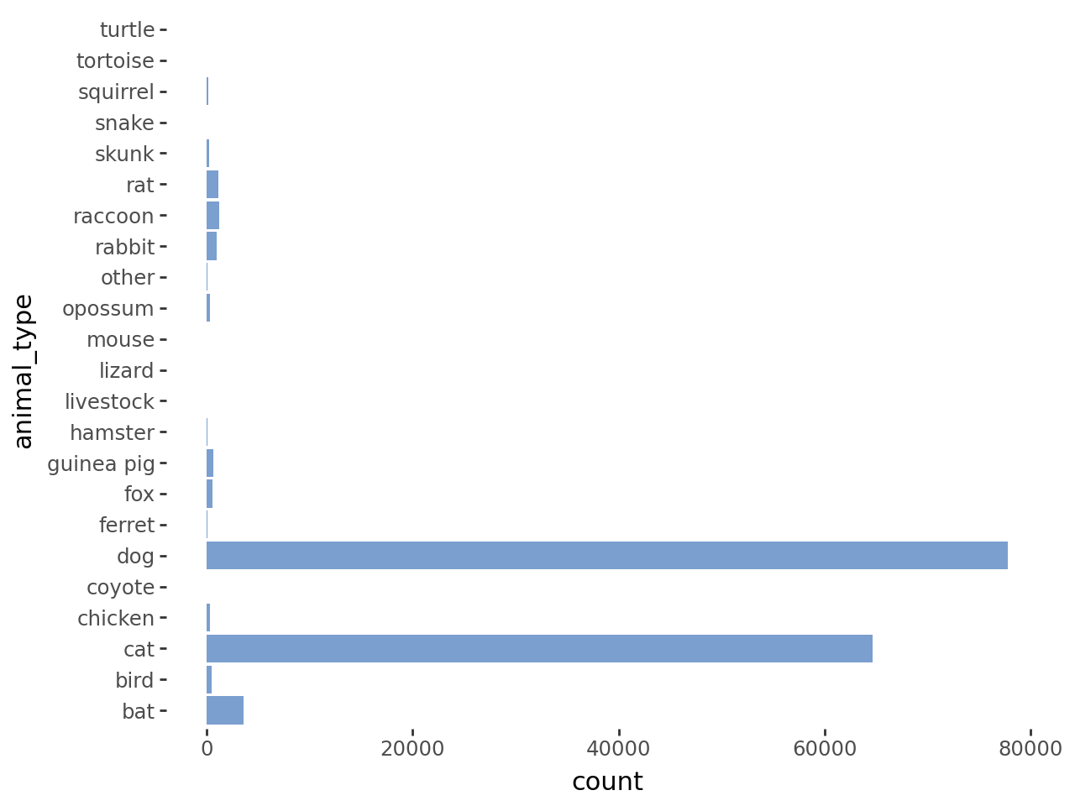

- Animal age is dominated by young animals. An overwhelming majority are below 3 years old, and the mode is less than one year old. However, age has a clear right skew with a large range.

Figure 2: distribution of age in the dataset
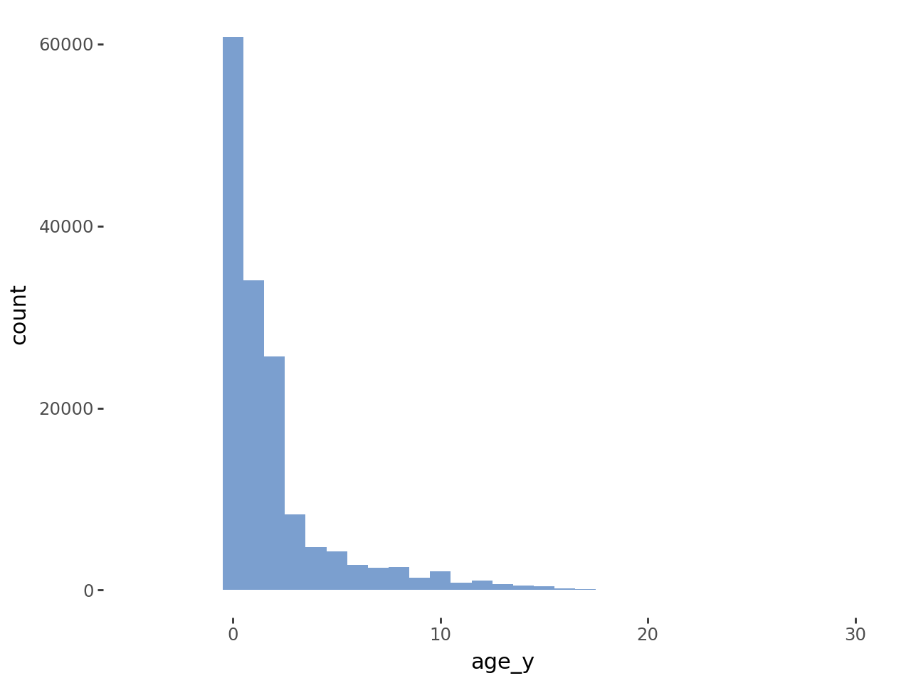

- Intake type is dominated by strays. Euthenasia request is a very small minority.

Figure 3: distribution of intake type in the dataset
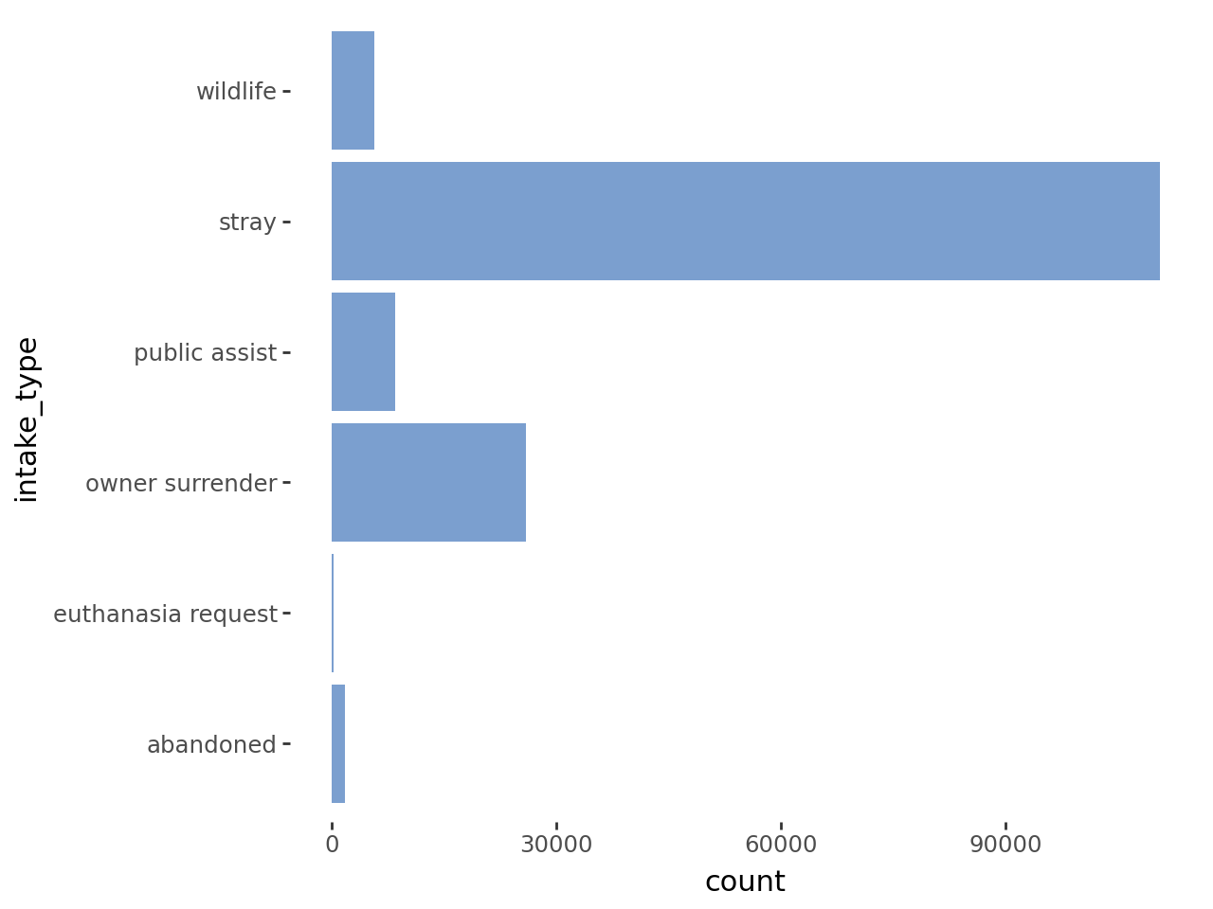

- For animals that were adopted, time spent in the shelter between intake and adoption is dominated by short stays, but has a large right skew.

Figure 4: distribution of shelter stay (in days) of the dataset
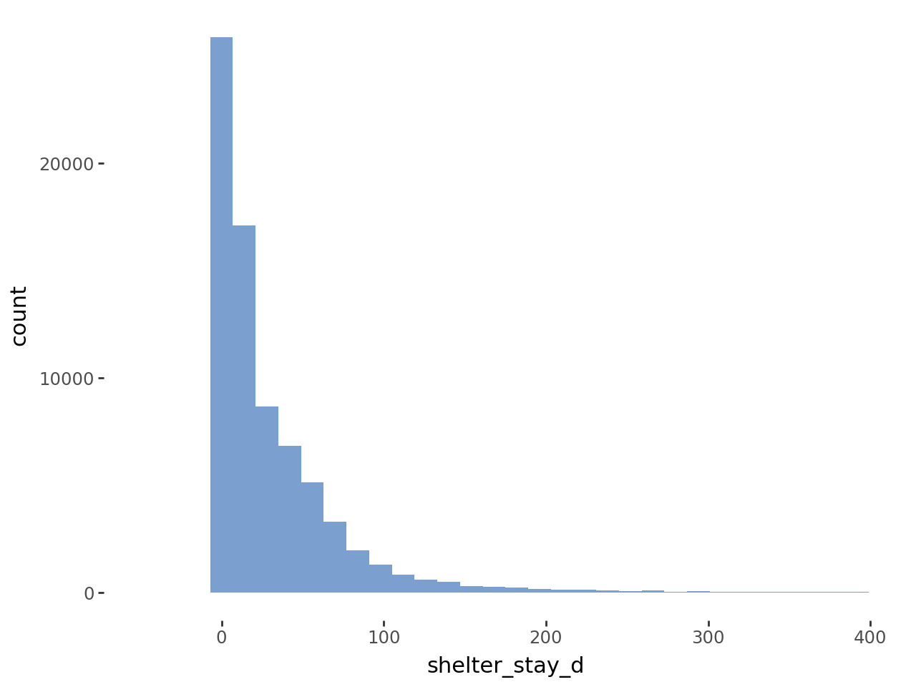

- The shelter is a no-kill shelter, so euthanasia makes up a minority of classes. Adoption is the most likely result by a healthy margin.

Figure 5: distribution of outcome type in the dataset
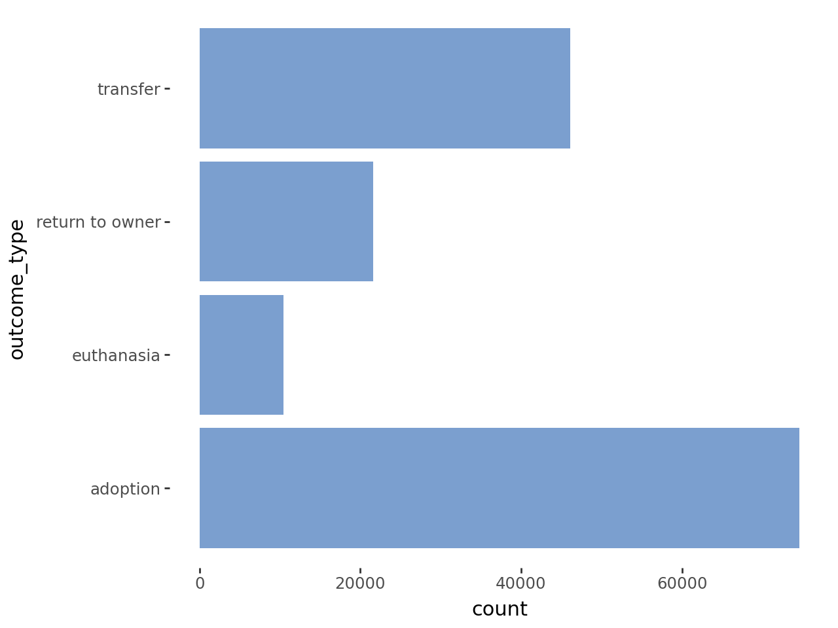

- Partitioning

Dataset partitioning varied on the model goal:
- Predicting outcome type: The data was partitioned 70% training, 30% test data. I used stratified sampling to ensure that the distribution of outcome classifications in the training and test set matched that of the original dataset.
- Predicting shelter stay duration of adopted animals: I first filtered the data to only contain adopted animals. I then discarded durations that were longer than 400 days to get rid of extreme outliers. From this, the dataset shrank to 74,000 instances. The data was partitioned 70% training, 30% test data. No partitioning was used.
- Identifying strong factors that lead to adoption: No partitioning was used. The entire dataset was used as the training data to identify strong predictive features that steer the outcome to adoption.

Section 4: Methods

For each of the three goals, I used an XGBoost model. Generally, XGBoost is one of the strongest models available. The model iterates through building trees, using each previous tree to train the next one. The model does this by increasing the weight of misclassified instances, which can also help in a dataset with an unequal distribution of classes, as we have here. However, the model is sensitive to outliers in the dataset. I attempted to control for this by filtering out outliers in ‘shelter stay duration’ and removing features with an insufficient amount of data. Another benefit of XGBoost is that the model objective can be changed, and can therefore adapt to the three different model goals that I have framed. Another downside of XGBoost is that it is less plug-and-play and requires tuning to get good results. While time consuming, I was able to sufficiently tune each of the models where tuning was appropriate (models a and b below)

- Predicting outcome type

I used a multiclass prediction XGBoost model to predict the ‘outcome type’ class (XGBoost objective multi:softmax). This option works best for the multiple possibilities of outcome type. In this problem, we have four outcome types.

- Predicting shelter stay duration

I used a gamma deviance prediction XGBoost model to predict the duration an animal stays in the shelter, in days (XGBoost objective reg:gamma). Gamma deviance modeling is particularly suited for modeling positive, nonzero, continuous data that is right skewed. Common use cases are wait times before service and insurance claim payouts. This should be appropriate for animal shelter stay, as the data is positive, non-zero, and shows a clear right skew (Figure 4)

- Extracting factors that predict an adoption outcome

I used a logistic regression prediction XGBoost model to find what factors increase the chance of an adoption outcome (XGBoost objective binary:logistic). This model was purely for analyzing factors that drove adoption probability, so it was not tuned.

Section 5: Results

Note that the third model, the binary logistic model, was used only to extract features that predict adoption. As such, it was not tuned, and I will not discuss accuracy results, as the entire dataset was used to train the model. The tuning parameters were set to the following:

Table 2: tuned hyperparameters for the deployed models
Hyperparameter | Description of effect | Multiclass model | Gamma deviance model | Binary logistic model
num_boost_round | More rounds leads to a more tuned model, but risks overfitting | 499 | 384 | 500
min_child_weight | Increase the number of samples needed to split a node; prevents overfitting | 5 | 30 | default
max_depth | Controls the depth of trees. Deeper offers more complexity and better prediction, but can lead to overfitting | 10 | 8 | default
eta | Learning rate. Lower rates lead to slower built, more complex models, but too low can prevent effective model learning | 0.3 | 0.1 | default
subsample | Percent of the training data during each model round. Can help prevent outliers from dominating the model | 0.9 | 1 | default
colsample_bytree | Percent of the features used per model round. Lower settings prevent a few features from dominating, and allow more subtle features to come through | 0.8 | 0.7 | default
gamma | Sets the minimum improvement needed to split another node. Prevents overfitting. | 0.05 | 0.2 | default

- Multiclass model predicting outcome type

For this model, we use classification accuracy to judge the results. The model performed relatively well, with a test set accuracy of 84.9% and a training accuracy 98.6%. Normally this would suggest overfitting, but any manual adjustments of hyperparameters that decreased training accuracy also decreased test accuracy. The lopsided distribution of outcome type made minority classes more difficult to predict, particularly euthenasia.

Figure 6: confusion matrix showing performance of the multiclass model predicting outcome type
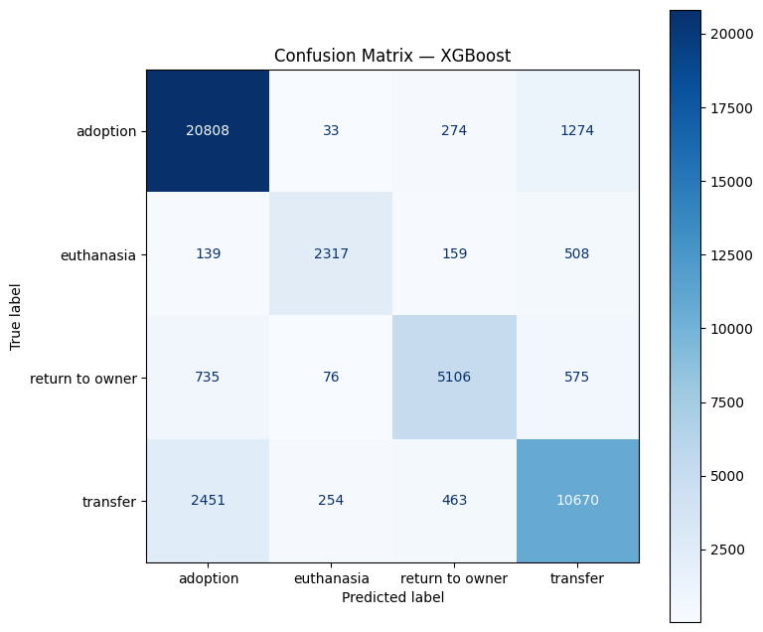

- Gamma deviance model predicting shelter stay

For this model, we use gamma deviance, which is an error metric, to measure performance. The mathematics of gamma deviance are beyond the scope of this report. For the purposes of this report, we will compare the model’s gamma deviance to the Null deviance. Null deviance measures the deviance metric if the model used the mean of the response variable for its predictions. For example, if the mean shelter stay is 3 days, the Null model predicts every animal will have a 3 day shelter stay, and then calculates the deviance of the actual values from that mean prediction.

The Null deviance for the model is 40.3, the test deviance is 19.6, and the train deviance is 15.6. This means that the model is 51.4% better at predicting than the Null. The train set in turn is 61.3% better than the Null. The relatively small difference in test and train deviance suggests that the model is not overfitting. While the performance is fairly good, the model struggles particularly with outlier data.

Figure 7: predicted vs true shelter day for the gamma deviance model, training set
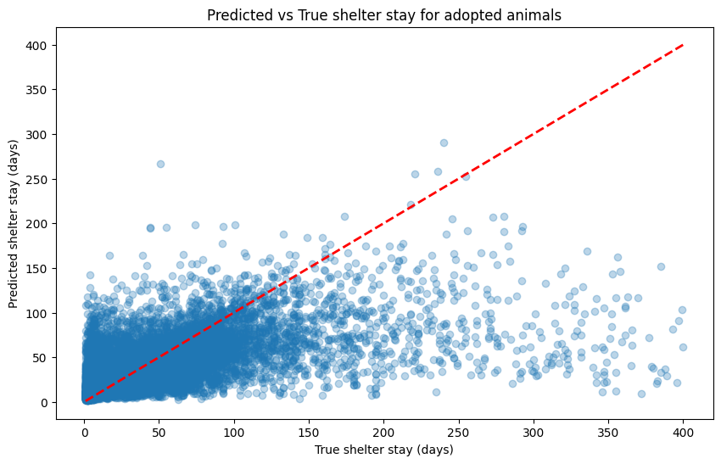
Section 6: Discussion

- Gamma deviance model predicting shelter stay

After fitting the model, I used the SHAP package to examine the factors that most strongly predict shelter stay:
- Predictors for a longer shelter stay
- Older animals
- Cats, rabbits
- Pit bulls, labs, staffordshires, catahoula hounds, boxer
- Injured, nursing, or neonatal animals
- Predictors for shorter stays
- Previously homed pets (owner surrender)
- Dogs
- Grey, tan, orange animals
- Dachshunds
- Purebreds
- Sick, nursing, and neonatal animals

Figure 8: top 40 factors to predict animal shelter duration, based on SHAP values
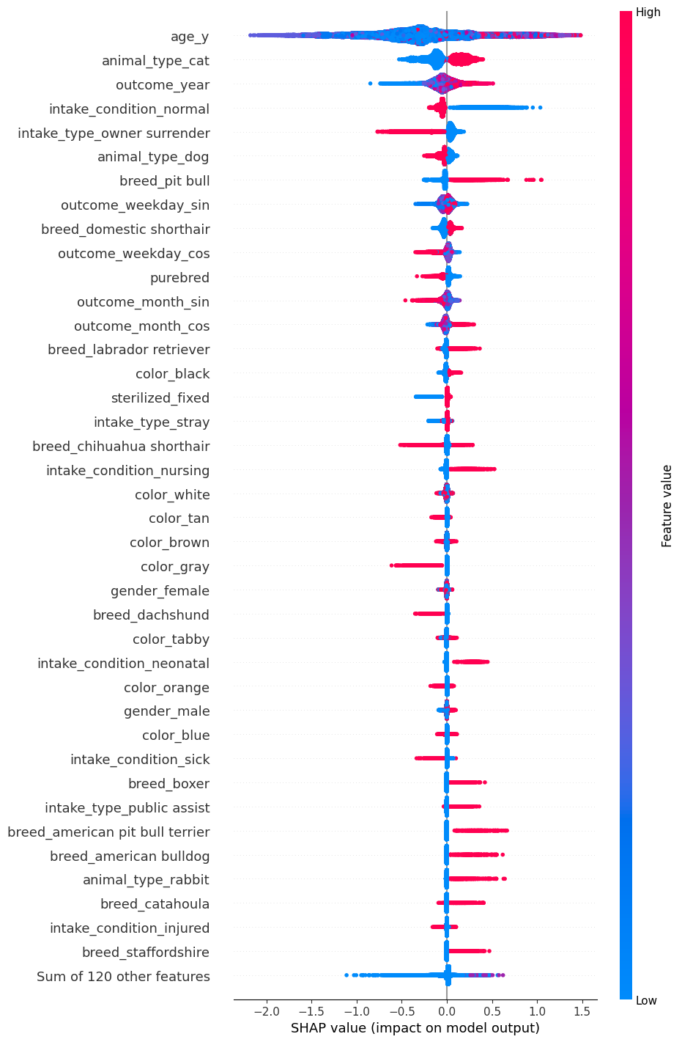

As a validation case, I ran the model against my dog, Athena. I adopted Athena two years ago, and she stayed in the shelter for an estimated 298 days before adoption. We risk bias of non-generalization, as I adopted Indiana rather than from the dataset location of Austin Nevertheless, this is a fun, non-scientific way to apply the model to real life.

Figure 9: my dog, Athena


Athena represents an outlier in the response variable, which the model struggles with. However, by extracting factors of most importance, a few patterns emerged:
- Athena’s breeds (american bulldog, german shepherd, boxer, australian cattle dog, non-purebred) predicted a longer stay
- All time data for Athena’s adoption date (2023, November, Friday) predict a longer stay
  - Note that month and weekday are sin-cos transformed and have two components each
- For this tree branch, being previously homed increased the predicted shelter stay. This shows that factor direction and important is nuanced and can vary when we use a tree model
- Not being a pitbull and being healthy upon intake predicted a shorter stay

Athena’s predicted shelter stay from the model is 4.9 days. This is well short of her actual stay of 298 days, which confirms that the model struggles against outliers, and perhaps cannot be generalized to predict for animals from the St Joseph County Humane Society. However, the model gets the direction of the prediction correct; Athena’s actual stay is above the mean. Additionally, the model is valuable to extracting factors that help and hurt Athena during her adoption process.

Figure 10: SHAP waterfall plot predicting Athena’s shelter stay (in days). Her actual shelter stay was 298 days.
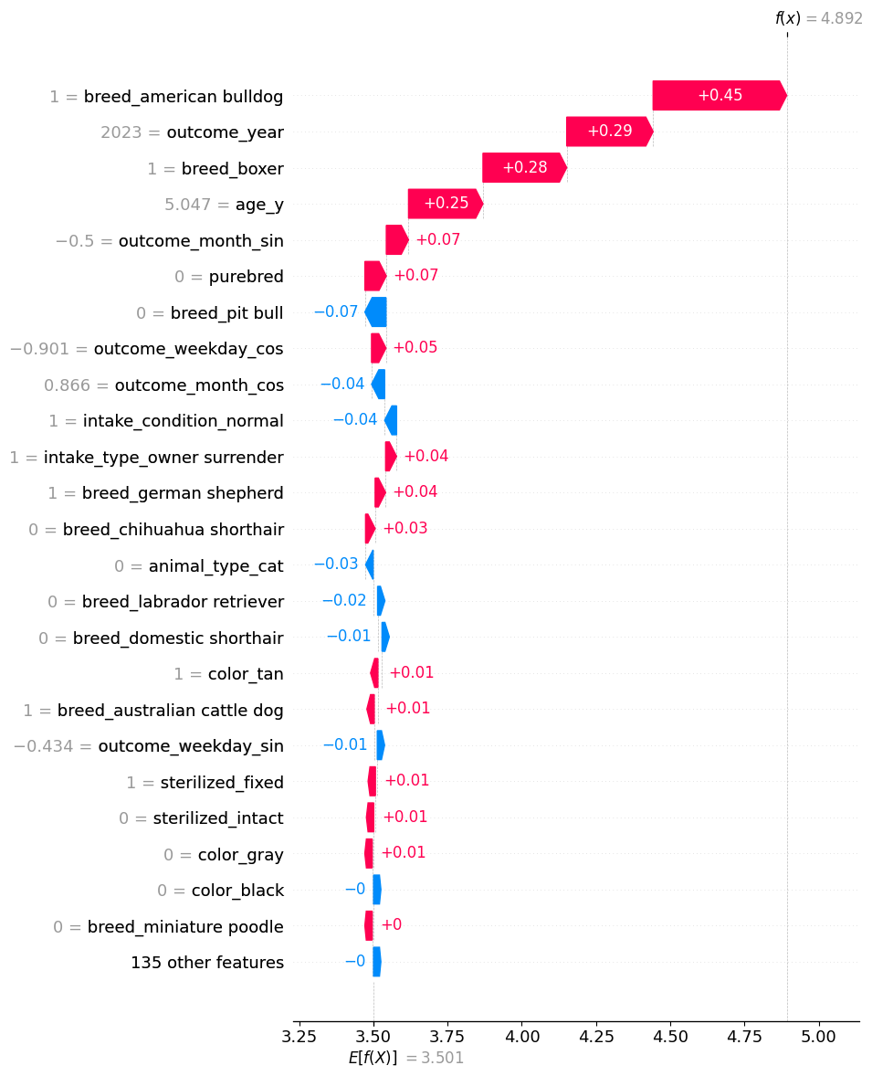

- Binary logistic regression extracting factors that predict adoption

After fitting the model, I used the SHAP package to examine the factors that most strongly predict a binary outcome of adoption:

- Predictors for adoption
- Sterilized, i.e. spayed or neutered
  - likely a shelter policy that all animals up for adoption are sterilized
- Longer durations in the shelter
  - Other outcomes, such as euthenasia or return to owner, usually happen quickly
- Previously homed animals
  - Likely desensitized to humans and somewhat trained
- Rabbits
- Female animals
- Labradors, chihuahuas
- Orange and point colored animals (point is a cat coat pattern, mostly associated with Siamese and Himalayan breeds)
- Predictors for non-adoption
- Wildlife, especially bats
  - Almost always euthanized
- Cats and dogs
  - Skewed by rabbits and birds, which are are almost always adopted
  - Likely skewed further by covariance between other variables like breed, color, intake type, etc
- Pit bulls
- Sick animals
- Male Animals

Figure 11: top 40 factors that influence the binary chance of adoption. Right of center is more probable for adoption, left of center is less probable for adoption.
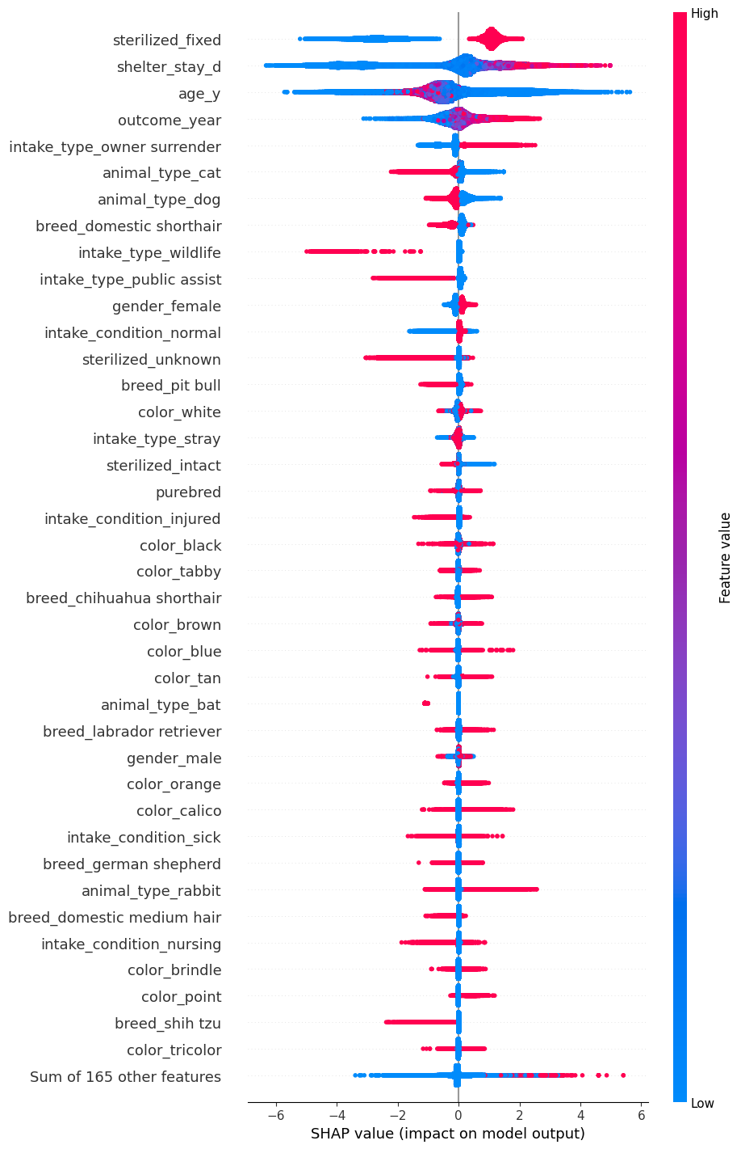

- Takeaways and recommendations

Based on the results of the model, there are a few recommendations that I can make to animal shelters. No doubt some of these are already well known to shelter workers, but it is still valuable to empirically confirm previous assumptions and more confidently make decisions moving forward. The recommendations are:

- Prioritize promotion, meet-and-greets, and fostering on less desirable animals, such as non-purebreds, pit bulls, german shepherds, boxers, and surprisingly labradors. As many can attest, these animals can make lovely pets, and we need to fight against preconceived biases against them. For labradors, perhaps these animals are overlooked because they are assumed to be desired, and therefore stay in the shelter longer than average

- For strays, prioritize socialization and basic training. This is probably already a main focus for shelters, but the model confirms that previously homed pets have better outcomes and shorter stays, which is likely because they are already accustomed to a home environment. Further research, ideally using behavioral data, is needed to confirm this.

- Find avenues for adoption for cats and bunnies, who often stay in the shelter longer before adoption. In particular, rabbits are usually viewed as a niche pet, and often overlooked as an option. Advertise the joys of rabbit ownership, and highlight particularly how they are social animals who do best with other rabbits, which can promote people adopting multiple animals.

- Consider introducing a wildlife rehabilitation and release program, or partnering with a wildlife organization that can run such a program. Most wildlife that end up in the shelter are euthanized, when these animals may be healthy and have a positive impact on their ecosystems. For example, Opossums – which are in the dataset and are often euthanized – eat pests and are virtually immune to rabies, meaning they pose almost no risk to public health.

Section 7: Conclusion

With more time and resources, there are a few next steps that would lead to better model results and better analysis:
- Use a different modeling technique, k-Means or k-mixed clustering, to group animals together and draw conclusions about the groups. My dataset contains a lot of categorical data, which k-Means does not handle well, so extensive data cleaning is required to pursue this.
- Continue to refine the dataset to remove covariant factors. Particularly, intake_type wildlife is very correlated to animal_type opossum, bat, squirrel, etc. There also appears to be covariance in age and intake_type nursing/neonatal.
- Remove time factors from the models (year, month, weekday). These proved to be difficult to interpret, and I question the validity of their predictive power in the model. Time factors can be better analyzed by visualizing aggregated outcomes over time.

Animal shelters, despite the best efforts of the amazing, caring, and tireless people who work there, are not good places to be. Shelters are often overstrained and understaffed, and animals that are housed there out of necessity are not able to get the socialization, exercise, and love that they need. I hope that with this project, I have identified some useful trends that shelter staff can use to drive better outcomes for animals. Focusing efforts on stereotypically unfavorable animals – such as cats, bunnies, pit bulls, and non-purebreds – can help them to overcome prejudices against them. Training and socialization efforts for stray animals can prepare them for their forever home. And, perhaps there is a path for wildlife to return to the wild. Even if all of the conclusions and recommendations in this paper are not new to Animal Shelter staff, I hope that this analysis confirms previous assumptions and gives workers confidence in their efforts to help animals. I also hope that this paper inspires you, the reader, to consider adopting an animal if you are financially, physically, and socially able to!

Works Cited

- Austin Animal Center. (2025, May 5). Austin Animal Center Intakes (10/01/2013 to 05/05/2025). City of Austin, Texas Open Data Portal. Retrieved November 11, 2025, from https://data.austintexas.gov/Health-and-Community-Services/Austin-Animal-Center-Intakes-10-01-2013-to-05-05-2/wter-evkm/about_data

- Austin Animal Center. (2025, May 5). Austin Animal Center Outcomes (10/01/2013 to 05/05/2025). City of Austin, Texas Open Data Portal. Retrieved November 11, 2025, from https://data.austintexas.gov/Health-and-Community-Services/Austin-Animal-Center-Outcomes-10-01-2013-to-05-05-/9t4d-g238/about_data

- Lepper, M., Kass, P. H., & Hart, L. A. (2002). Prediction of Adoption Versus Euthanasia Among Dogs and Cats in a California Animal Shelter. Journal of Applied Animal Welfare Science, 5(1), 29–42. https://doi.org/10.1207/s15327604jaws0501_3

- Kay, A., Coe, J. B., Young, I., & Pearl, D. (2018). Factors Influencing Time to Adoption for Dogs in a Provincial Shelter System in Canada. Journal of Applied Animal Welfare Science, 21(4), 375–388. https://doi.org/10.1080/10888705.2018.1436917

- Zadeh, A., Combs, K., Burkey, B., Dop, J., Duffy, K., & Nosoudi, N. (2022). Pet analytics: Predicting adoption speed of pets from their online profiles. Expert Systems with Applications, 204, 117596. https://doi.org/10.1016/j.eswa.2022.117596

- Cain, C. J., Woodruff, K. A., & Smith, D. R. (2020). Phenotypic Characteristics Associated with Shelter Dog Adoption in the United States. Animals, 10(11), 1959. https://doi.org/10.3390/ani10111959

- Bradley, J., & Rajendran, S. (2021). Increasing adoption rates at animal shelters: a two-phase approach to predict length of stay and optimal shelter allocation. BMC Veterinary Research, 17(1). https://doi.org/10.1186/s12917-020-02728-2

- Posage, J. M., Bartlett, P. C., & Thomas, D. K. (1998). Determining factors for successful adoption of dogs from an animal shelter. Journal of the American Veterinary Medical Association, 213(4), 478–482. https://doi.org/10.2460/javma.1998.213.04.478

- Siettou, C., Fraser, I. M., & Fraser, R. W. (2014). Investigating Some of the Factors That Influence “Consumer” Choice When Adopting a Shelter Dog in the United Kingdom. Journal of Applied Animal Welfare Science, 17(2), 136–147. https://doi.org/10.1080/10888705.2014.883924

- Brown, W. P., Davidson, J. P., & Zuefle, M. E. (2013). Effects of Phenotypic Characteristics on the Length of Stay of Dogs at Two No Kill Animal Shelters. Journal of Applied Animal Welfare Science, 16(1), 2–18. https://doi.org/10.1080/10888705.2013.740967

- Cohen, S. E., & Todd, P. M. (2019). Stated and revealed preferences in companion animal choice. Behavior Research Methods, 51(4), 1498–1509. https://doi.org/10.3758/s13428-019-01253-x

- Protopopova, A., Mehrkam, L. R., Boggess, M. M., & Wynne, C. D. L. (2014). In-Kennel Behavior Predicts Length of Stay in Shelter Dogs. PLoS ONE, 9(12), e114319. https://doi.org/10.1371/journal.pone.0114319

Appendix

- Link to project folder, containing this report, final project presentation, and exports of the datasets
  - https://drive.google.com/drive/folders/1wmR3mus0dW5DeavB3BD-Wfd_qiGKFHzK?usp=sharing

